

February 16, 2018

Dr. Christopher Maples Interim Chancellor

Missouri University of Science & Technology 300 West 13th Street

206 Parker Hall

Rolla, MO 65409

Dear President Maples:

Attached is the Quality Initiative Report (QIR) Review evaluation information. Missouri University of Science & Technology’s QIR showed genuine effort and has been accepted by the Commission. The attached reviewer evaluation contains a rationale for this outcome.

Peer reviewers evaluate all the QIRs based on the genuine effort of the institution, the seriousness of the undertaking, the significance of scope and impact of the work, the genuineness of the commitment to the initiative, and adequate resource provision.

If you have questions about the QIR reviewer information, please contact either Kathy Bijak [(kbijak@hlcommission.org)](mailto:(kbijak@hlcommission.org) or Pat Newton-Curran [(pnewton@hlcommission.org).](mailto:(pnewton@hlcommission.org)

***Higher Learning Commission***

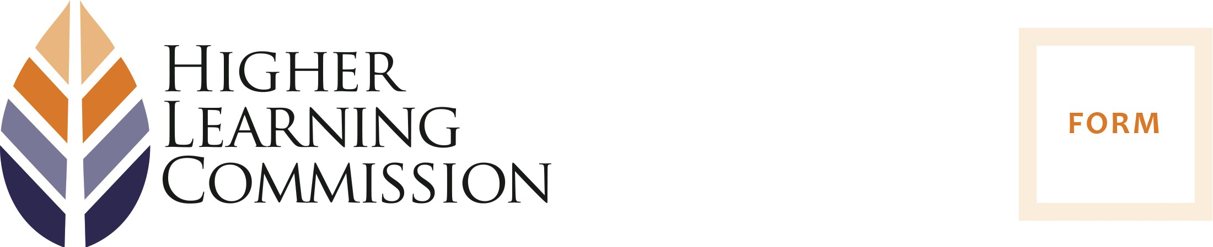

**Open Pathway Quality Initiative Report**

*Panel Review and Recommendation Form*

The Quality Initiative panel review process confirms or questions the institution’s effort in undertaking the Quality Initiative proposal approved by the Commission. As indicated in the explication of the review, the Quality Initiative process encourages institutions to take risks, innovate, take on a tough challenge, or pursue a yet unproven strategy or hypothesis. Thus failure of an initiative to achieve its goals is acceptable. An institution may learn much from such failure. What is not acceptable is failure of the institution to pursue the initiative with genuine effort. Genuineness of effort, not success of the initiative, constitutes the focus of the Quality Initiative review and serves as its sole point of evaluation.

Name of Institution: Missouri University of Science & Technology State: MO

Institutional ID: 1471

Reviewers (names, titles, institutions): Dr. Amy Stein, Yavapai College Linda Stacy, University of Toledo - Retired

Date: February 13, 2018

# Quality Initiative Review

Checkbox The institution demonstrated its seriousness of the undertaking.

Checkbox The institution demonstrated that the initiative had scope and impact.

Checkbox The institution demonstrated a commitment to and engagement in the initiative.

checkbox The institution demonstrated adequate resource provision.

# Recommendation

checkbox The panel confirms genuine effort on the part of the institution.

Checkbox The panel cannot confirm genuine effort on the part of the institution.

# Rationale (required)

To address a primary goal within the Missouri University of Science and Technology Strategic Plan, the institution worked toward the development and implementation of a new degree requirement through which students would engage in activities directly related to their respective fields of study. The requirement, reminiscent of a senior project or practicum is identified as a "significant experiential learning activity." The Quality Initiative project is a work in progress as the institution itself continues to learn from the experience. The ultimate objective of the project is to enhance the curriculum and to "Develop and inspire creative thinkers and leaders for life-long success." Including such as "experiencial" requirement into a degree program and thuse providing students with practical application of their education is certainly a practical step toward this instructional goal.

The progress made thus far on the project incorporated the experience, expertise and contribuitions of the entire educational community including, but not limited to, the administration, faculty, staff, students, and alumni. Key to this curricular change were the contributions and oversight provided by the faculty committees. The committees ensured the breadth and depth of the criteria and guidelines for the requirement from college to college.

As noted in the report, there was and is support for the concept and requirement of this experiential learning activity. Missouri University should be commended for the transparency articulated in their report with respect to the challenges and concerns of such an implementation. Further, the Faculty Senate and Academic Freedom and Standards committee must be recognized for the participation and stewardship as such a project includes thorough investigation to ensure the multi-faceted possibilities from discipline to discipline are considered and respected. There is little doubt that such an endeavor, be it in progress, or at its completion could be achieved without the contributions of the University community at large.

The progress thus far was accomplished by the community of professionals engaged in the project. No additonal financial resources were employed to work toward the curriculum development which is the foundation of this project. However, the institution recognizes that as an evolutionary process, financial resources will most likely be a necessity to support the faculty, staff, nformation technologies, and future activities related to the implementation of such an ambitious project.